Use-Case Realization Report (Analysis)
Change Cylinder Priority

Issue 1.0
Revision History
Date | Issue | Description | Author
29/Apr/2011 | 1.0 | Initial Document | Koh Ming Jin

Table of Contents
1. Brief Description 4
2. Flow of Events 4
2.1 Standard Flow 4
2.2 Exception 4
3. Interaction Diagrams 4
3.1 Collaboration Diagram for Change Cylinder Priority 4
4. Participating Objects 4
4.1 Change Cylinder Priority Page 4
4.2 Cylinder Controller 4
4.3 Cylinder 4
5. Class Diagrams 5
5.1 Domain Class Diagram: Change Cylinder Priority 5
6. Derived Requirements 5

Use-Case Realization Report
Change Cylinder Priority

Brief Description
This use case enables an operation manager to change the priority of a particular cylinder.

Flow of Events
The standard flow of events for this use case and any exceptions are described in the following subsections. See section 3.1 for an overview of the participating Actors and Domain Objects.

Standard Flow
The flow of events is described as follows:

- The use case starts when the authenticated Operation Manager views a list of cylinder details (please refer to view cylinder use case).
- The Operation Manager selects the Change Cylinder Priority option.
- The Change Cylinder Priority Screen, which enables the Operation Manager to change the cylinder’s priority, appears.
- The Operation Manager updates the cylinder’s priority.
- The use case terminates.

Exception
- NIL

Interaction Diagrams

Collaboration Diagram for Change Cylinder Priority
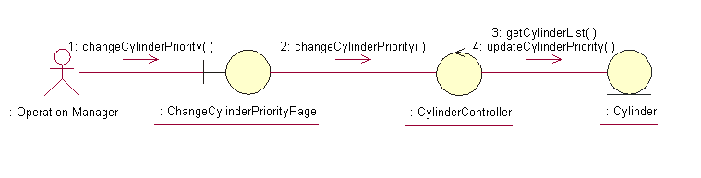

Participating Objects

Change Cylinder Priority Page
This object renders the contents to allow authorized actors to perform the update Cylinder priority request. The Director, Department Manager and Operation Manager actors use this object.

Cylinder Controller
This object acts as the middleman between “Change Cylinder Priority” Page and the Cylinder object. It will translate interactions with the view into actions to be performed by the Cylinder object.

Cylinder
This object stores the details concerning the cylinder information of the COMS.

Class Diagrams

Domain Class Diagram: Change Cylinder Priority
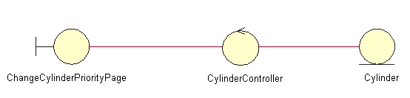

Derived Requirements
The Operation Manager PC keyboard and mouse will be used to enter Schedule details (if any) and view all the system responses.

